**JDBC-CURD OPERATIONS-24 may**

**IN MYSQL WORKBENCH**

show databases;

drop database vit;

create database vit;

use vit;

create table student(id int,name varchar(25),marks int);

insert into student values(101,'rama',89),(102,'rakesh',86),(103,'rahul',79),(104,'ravi',99),(105,'raju',89);

select * from student;

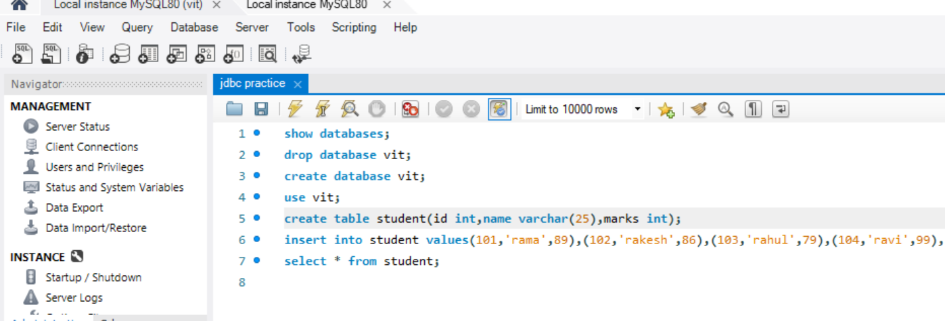

**IN JAVA ECLIPSE CURD_OPERATION FILE**

**package** crud_operator;

**import** java.sql.Connection;

**import** java.sql.PreparedStatement;

**public** **class** CRUD_Operation {

**public** **static** **void** main(String[] args) {

CRUD_Operation objTest=**new** CRUD_Operation();

objTest.create_data("103", "manoj", 55);

objTest.create_data("104", "karthick", 65);

}

**public** **void** create_data(String sl_no,String name,**int** mark){

DB_Connection obj_DB_Connection=**new** DB_Connection();

Connection connection=obj_DB_Connection.get_connection();

PreparedStatement ps=**null**;

**try** {

String query="insert into student values (?,?,?)";

ps=connection.prepareStatement(query);

ps.setString(1, sl_no);

ps.setString(2, name);

ps.setInt(3, mark);

System.***out***.println(ps);

ps.executeUpdate();

} **catch** (Exception e) {

System.***out***.println(e);

}}}

**IN JAVA ECLIPSE DB_CONNECTION FILE**

**package** crud_operator;

**import** java.sql.*;

**public** **class** DB_Connection {

**public** **static** **void** main(String [] args){

DB_Connection obj_DBConnection=**new** DB_Connection();

System.***out***.println(obj_DBConnection.get_connection());

}

**public** Connection get_connection(){

Connection connection=**null**;

**try**{

Class.*forName*("com.mysql.cj.jdbc.Driver");

connection = DriverManager.*getConnection*("jdbc:mysql://localhost:3306/vit","root","Savitri853218@");

}**catch**(Exception e){

System.***out***.println(e);

}

**return** connection;

}

}

